**What are values ?**

Values are ideals or beliefs that people hold, which help them determine what is desirable or undesirable.

Values can be personal or societal. Personal values are those that people hold close to themselves and that guide their actions and decisions. Societal values are those that guide people's interactions with others and the world around them.

**Process of Socialization / Socialization**

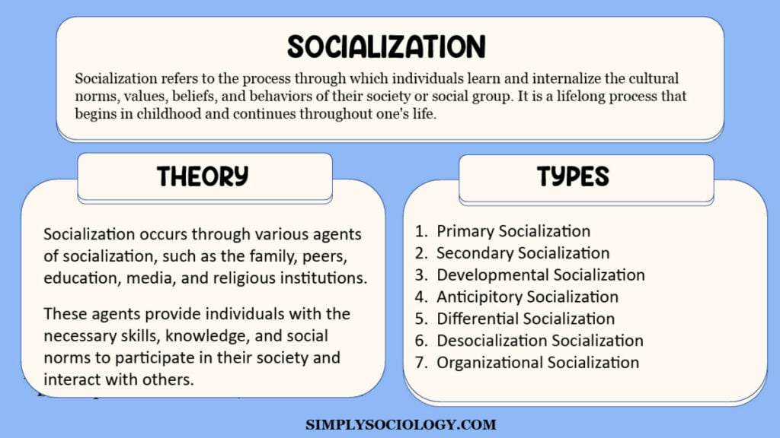

**Integrated Personality**

An integrated personality is a personality that combines different aspects of a person's identity, beliefs, values, emotions, and behaviors into a cohesive whole. It reflects a person's ability to align their thoughts, feelings, and actions in a consistent and authentic manner.

According to Rogers, an integrated person is unified within themselves at all levels and with low discrepancy between the present self and the desired self.

**Social values : -**

Characteristics: -

1. **Subjectivity**: Social values are subjective and can vary among different groups, cultures, or individuals. What one society considers a core value might differ from another's perspective.
2. **Dynamic Nature**: Values can evolve over time due to societal changes, cultural shifts, or generational differences. For instance, societal attitudes toward issues like LGBTQ+ rights or environmental conservation have evolved over the years.
3. **Influence on Behavior**: Social values shape individuals' behavior, decision-making processes, and attitudes. They guide how people interact with others, make choices, and prioritize goals in life.
4. **Transmission and Learning**: Values are often passed down through generations via social institutions like families, educational systems, religious institutions, and the media. People learn and adopt values from their environment and upbringing.



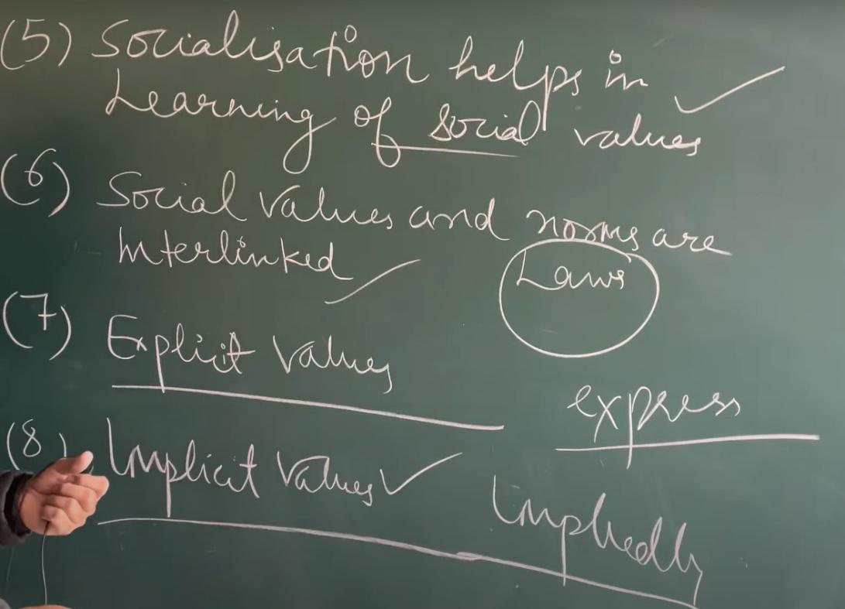



1. **Social justice** --> Social justice promotes fairness and equity across many aspects of society. For example, it promotes equal economic, educational and workplace opportunities. It’s also important to the safety and security of individuals and communities. According to the National Education Association (NEA) “The absence of social justice results in social oppression.” The NEA notes this could be in the form of “racism, sexism, ageism, classism, ableism, and heterosexism.” It also suggests the following strategies for promoting social justice:

a) Concentrate on diversity

b) Confront the implications of oppression

c) Learn and address the attitudes and behaviors that sustain oppression

d) Adopt an inclusive mindset

Social workers apply the above strategies to advance growth and change among vulnerable groups, such the senior, LGBTQ, homeless, veteran and refugee communities.





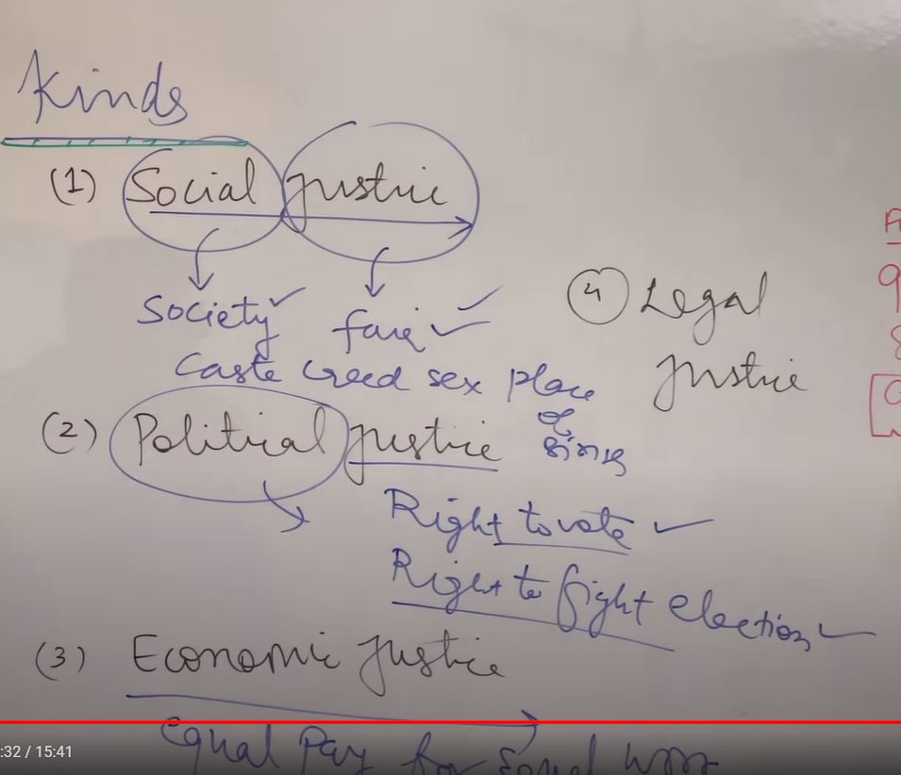



**Aesthetic values**

Aesthetic value is the value that an object, event, or state of affairs possesses in virtue of its capacity to elicit pleasure or displeasure when appreciated or experienced aesthetically.

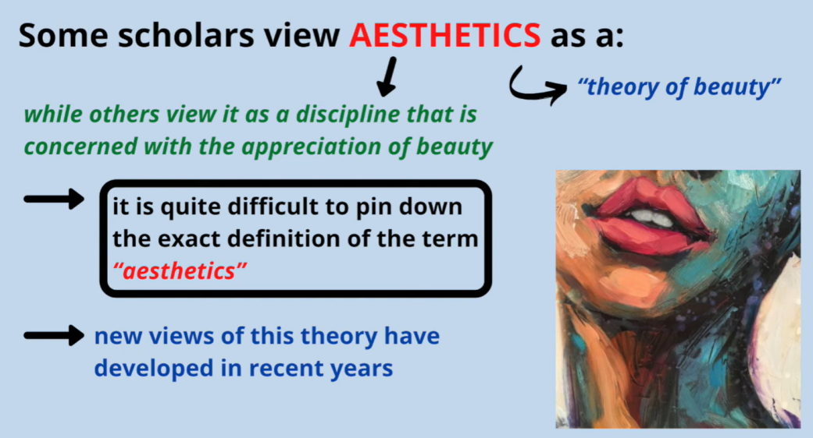

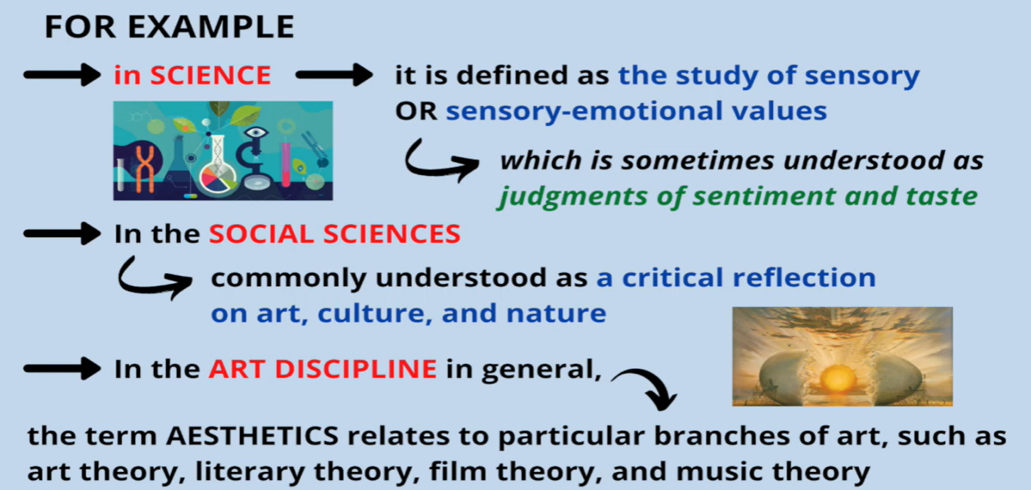

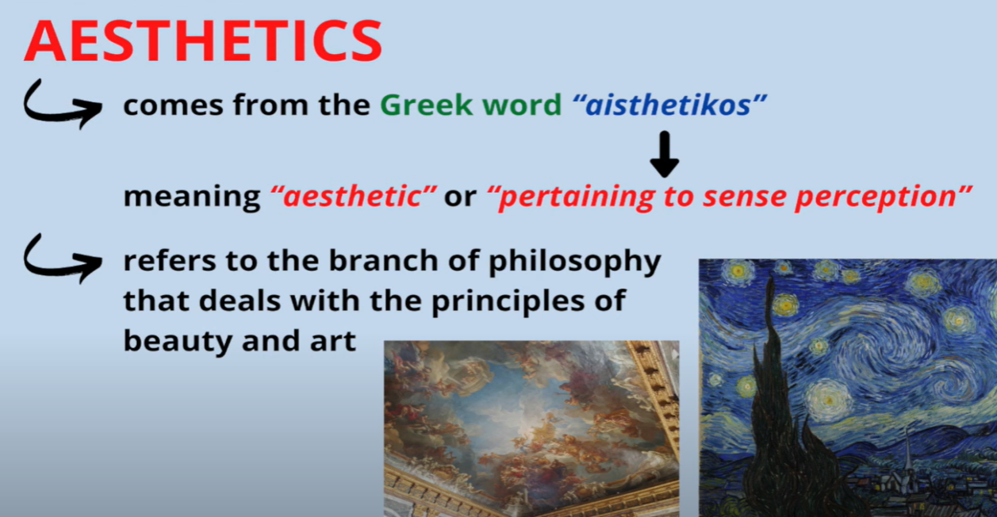

**Appreciation of beauty** --> Appreciation of beauty and excellence is the ability to identify and enjoy what is admirable in the world. Appreciation of beauty can be physical, such as a sunset, song, or building. It can also be an exceptional skill or talent, or moral goodness, such as a character strength.

Appreciation of beauty can be a psychological trait, which is the immediate emotional experience of feeling something beautiful.

Some examples of appreciation of beauty and excellence include:

1. Creating a beautiful workspace
2. Connecting with nature
3. Hunting for greatness
4. Listening for excellence

**Organizational values**

Organizational values are a set of core beliefs held by an organization. They act as guiding principles that provide an organization with purpose and direction and set the tone for its interactions with its customers, employees and other stakeholders.

Your organizational values should be authentic and unique to your company. They should state clearly how you expect the people who work for you to act and guide them in their decision-making.

|  |  |
| --- | --- |
| **Employee** | **Employer** |
| An employee holds a specific job role in the organization | An employer holds a leadership/ownership position in the organization |
| An employee performs tasks / responsibilities assigned by the employer. | An employer sets directions and oversees the operation |
| An employee performs works within the framework or guidelines set by the employer | Holds decision-making authority in the organization |
| Limited involvement in major decisions | Holds decision making power |
| Hired by the employer based on the qualification and suitability | Holds the power to hire and fire an employee |
| Receive compensation in exchange of work | Has the responsibility to pay salaries / wages to other employees |

Rights of an Employee :-

1. **Fair wages** - Employees have the right to fair wages and overtime pay.
2. **Safe workplace** - Employees have the right to a safe and healthy workplace free from harassment and bullying.
3. **Non-discrimination** - Employees have the right to be treated equally regardless of their race, religion, gender, or other protected characteristic.
4. **Employment agreement** - Employees have the right to receive an employment agreement that outlines the terms and conditions of their employment.
5. **Filing complaints** - Employees have the right to file a complaint if they believe their rights have been violated.
6. **Medical leave** - Employees are entitled to job-protected and unpaid leave for specified medical and family reasons.
7. **Protection schemes** - Employees are protected by schemes that ensure they are covered if they are injured while working.
8. **Business transfers** - Employees' employment rights are protected when the business they work for transfers to a new employer.

Rights pf an Employer :-

1. **Right to hire and fire** - The right to employment in India provides that an employer in India has all the rights and entitlement to hire the most suitable employee for their company. An employer’s rights include his choice to select the best candidate that fits the job profile, based on a person’s qualifications, knowledge, and experience. However, an employer cannot discriminate against candidates on the basis of their caste, religion, gender or age.
2. **Right to confidentiality/non-disclosure** - Employer rights in India are to protect their client information and trade secrets. For this, an employer can get a Non-Disclosure Agreement (NDA) signed by its employees. As the not only employer is dealing with client information and trade secrets but the said information is also accessible to employees especially senior and middle management of an organization.
3. **Right to implement a work policy** - An employer can define the code of conduct for employees, working hours, timings, leave policy, salary policy, conditions for termination and resignation, harassment policy and grievance redressal policy in the working policy.
4. **Right to receive notice of resignation** - Employer rights in India also give an employer the right to receive notice of resignation before an employee leaves the company. The employee has to serve a notice period before resigning so that the employer has sufficient time to hire a replacement. The notice period generally ranges from 1 week to 1 month depending upon the company’s HR policy.
5. **Right to be notified of employee’s leave** - Employer rights in India entitle an employer with the right to be notified before the employer takes a leave from office. The employer also has the right to reject or approve the leave application of an employee. An employer can reject the leave application if the employee constant absents them from office, fails to perform their duties, or take leaves without any substantial reason.

**Psychological values**

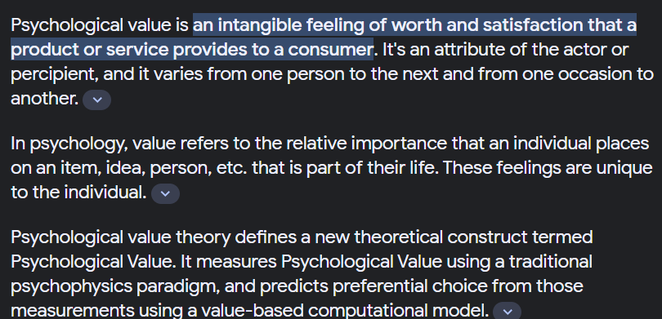

**Mental health**

Mental health includes our emotional, psychological, and social well-being. It affects how we think, feel, and act, and helps determine how we handle stress, relate to others, and make choices.

Mental health is important at every stage of life, from childhood and adolescence through adulthood. Over the course of your life, if you experience [mental health problems](https://www.samhsa.gov/mental-health/how-to-talk/people-with-mental-health-problems), your thinking, mood, and behavior could be affected.